Task on Secure Serverless Architecture with AWS SSM, WAF, SQS & MQ
- AWS Systems Manager Parameter Store
Steps:
- Create Lambda Function
- Login to Amazon Web Services console
- Open Lambda
- Click Create Function
- Choose Author from scratch

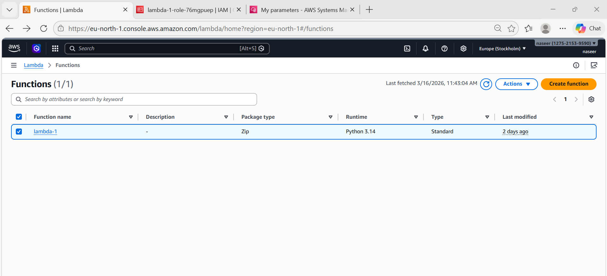
Attach policies:
- AmazonSSMFullAccess
- AmazonSQSFullAccess
- AWSLambdaBasicExecutionRole
Click Save

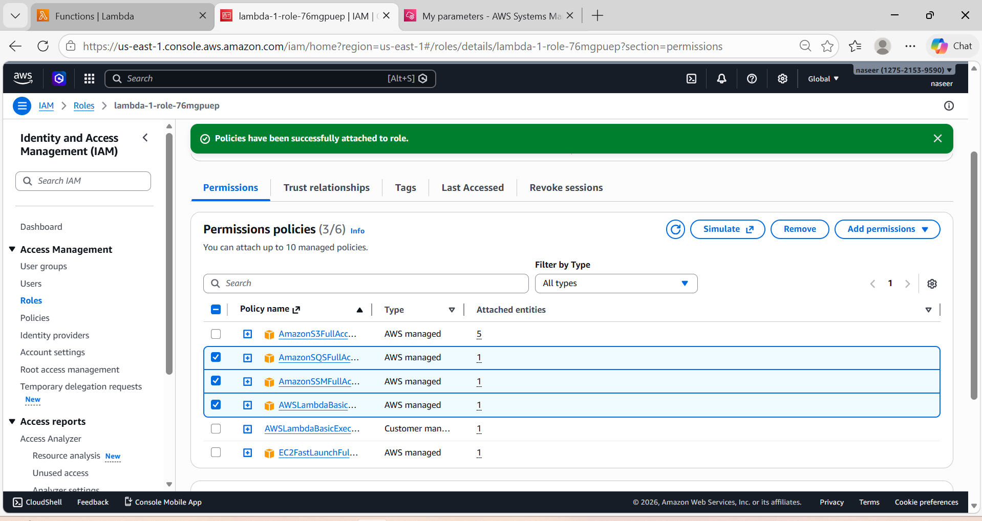
Step 1
Open AWS ConsoleGo to Systems ManagerSelect Parameter Store
Click Create Parameter
Name: /prod/db/password
Type: SecureString
Value: mypassword123
Encryption: AWS KMS
Save parameter

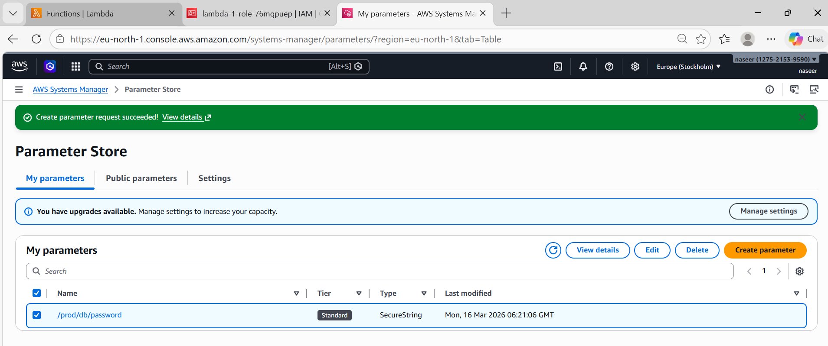
import boto3

ssm = boto3.client('ssm')

def lambda_handler(event, context):

response = ssm.get_parameter(
Name='/prod/db/password',
WithDecryption=True
)

password = response['Parameter']['Value']

print(password)

return {
"statusCode": 200,
"body": password
}
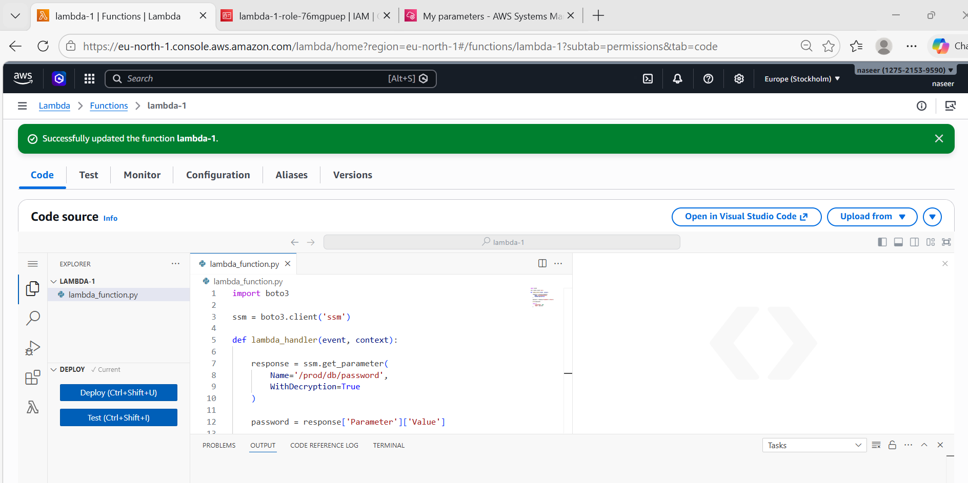

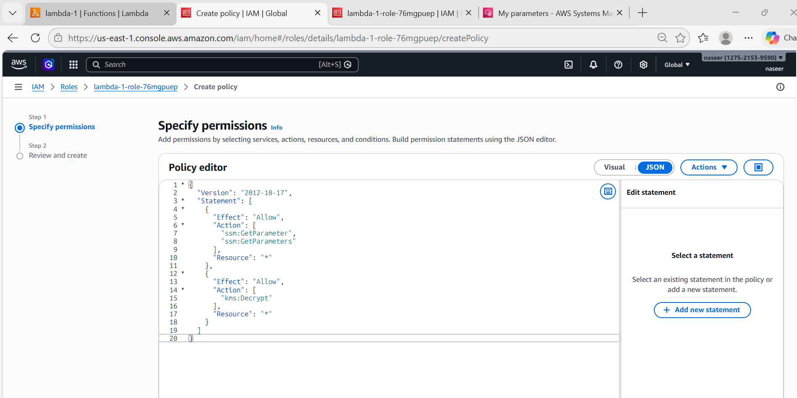
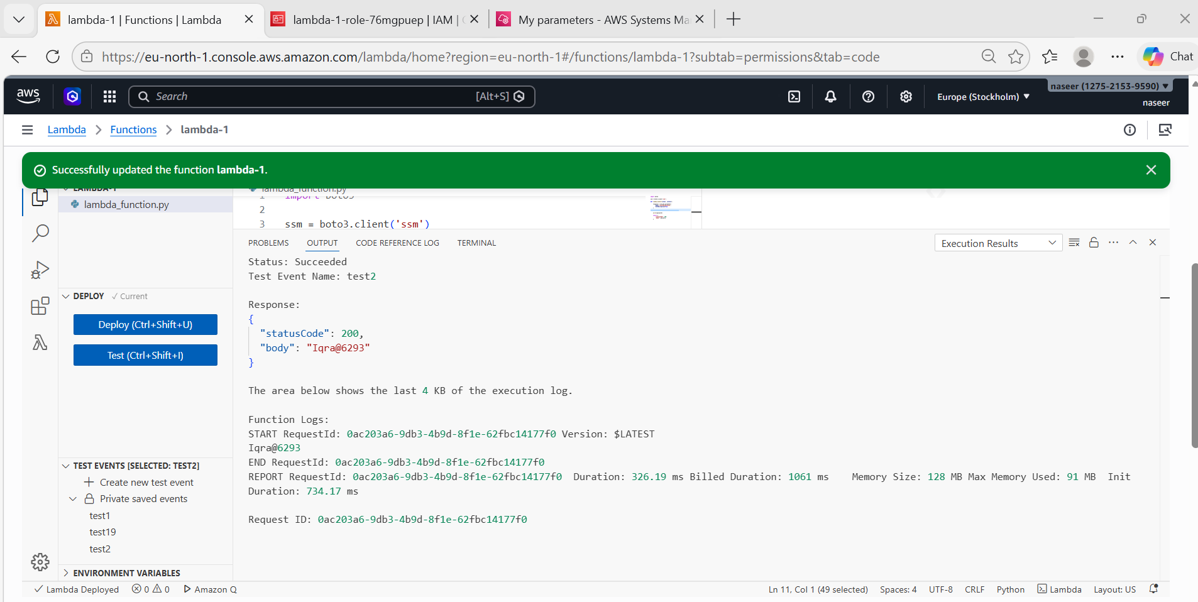

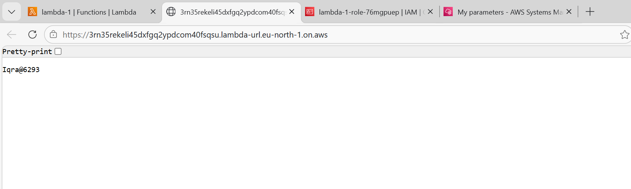

Store a Parameter in Parameter Store using Lambda
Steps:
- Create Lambda Function
Login to AWSOpen LambdaClick Create FunctionChoose Author from scratch
- Give Permission
Lambda needs permission to store parameters.
Open ConfigurationClick PermissionsOpen Execution Role
Attach policy: AmazonSSMFullAccess
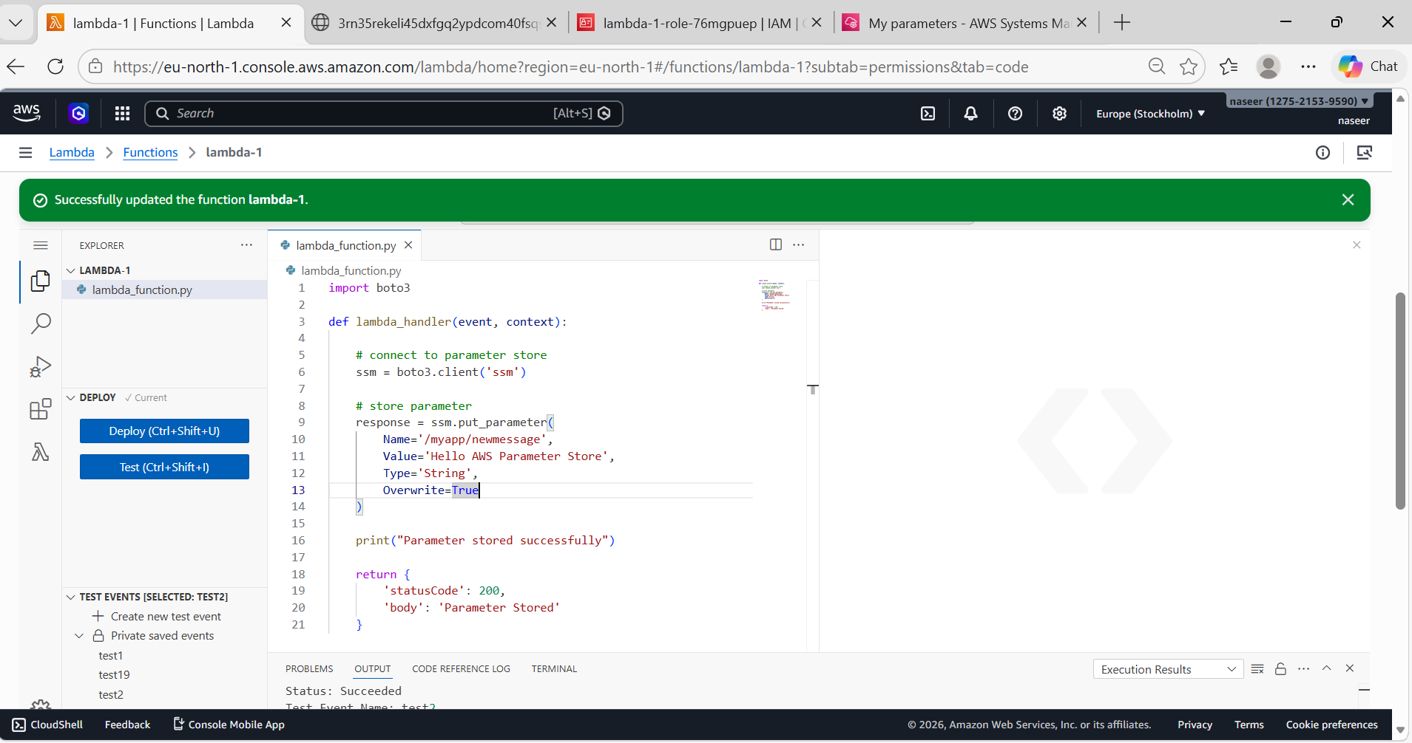
- Deploy and Test
Click Deploy
Click Test
Run the Lambda function.
Output: Parameter stored successfully

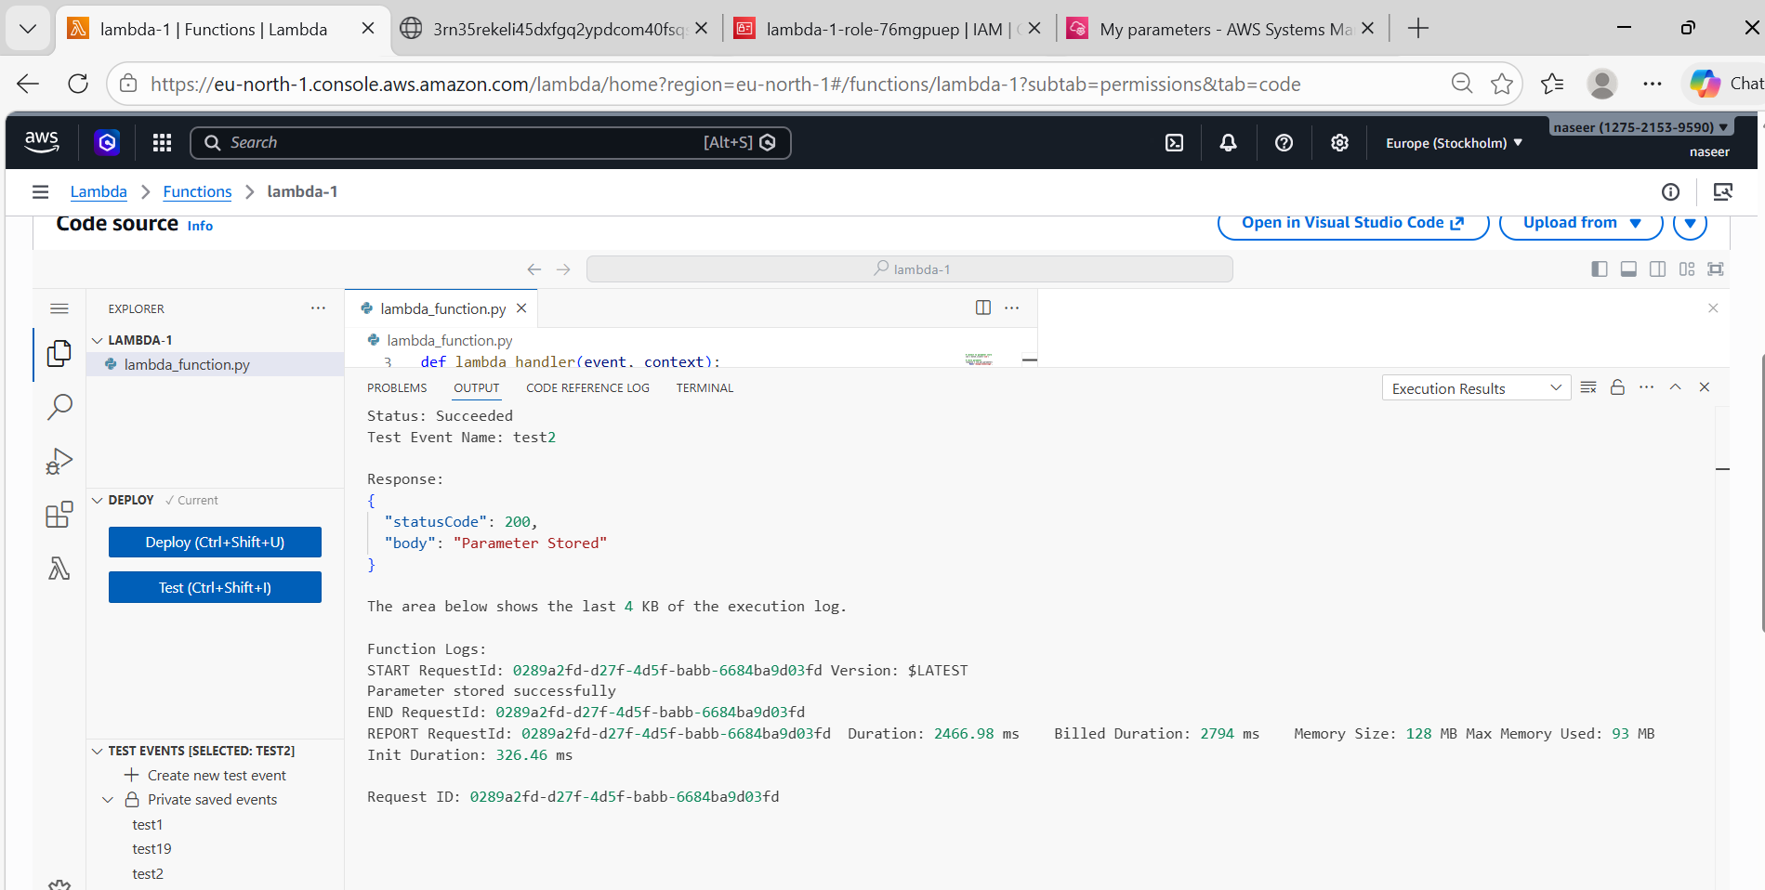
- Verify Parameter
Open AWS Systems Manager Parameter Store
- Check parameter: /myapp/newmessage
Architecture Flow
User
↓
AWS Lambda
↓
Parameter Store
↓
Store configuration value

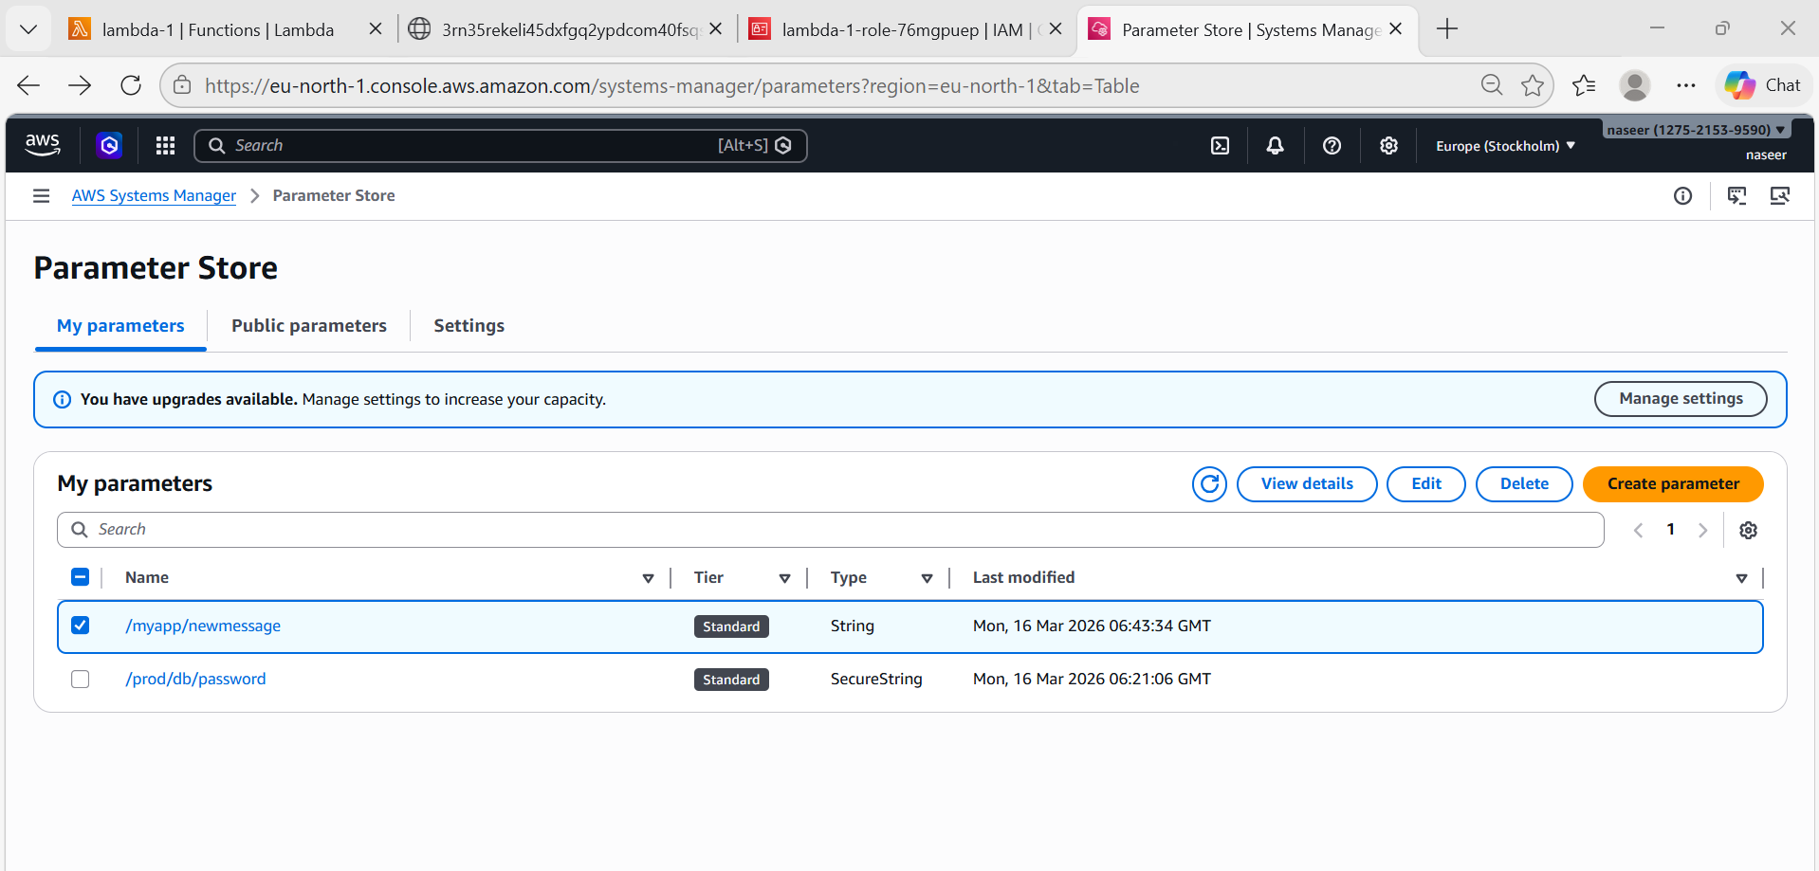
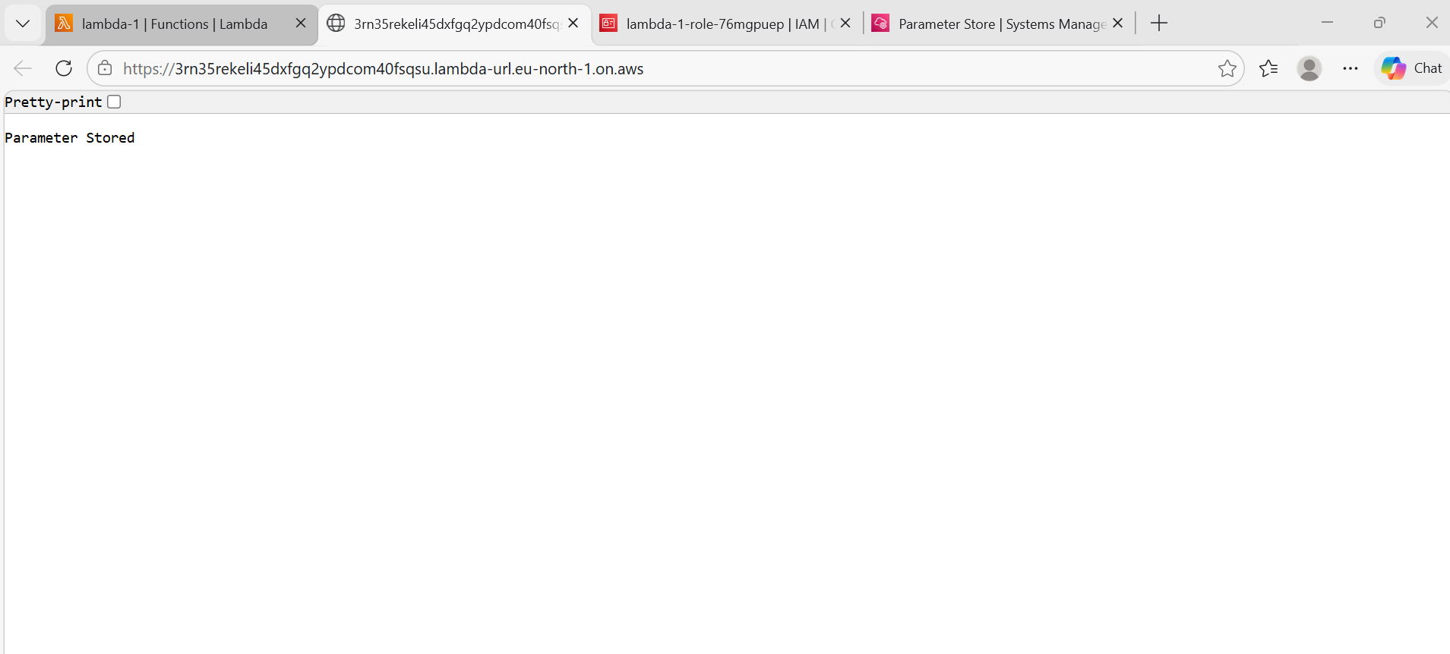
- AWS Web Application Firewall (WAF)
Steps:
Open AWS ConsoleSearch AWS WAFClick on Create Web ACL
Choose resource: API Gateway
or
Application Load Balancer

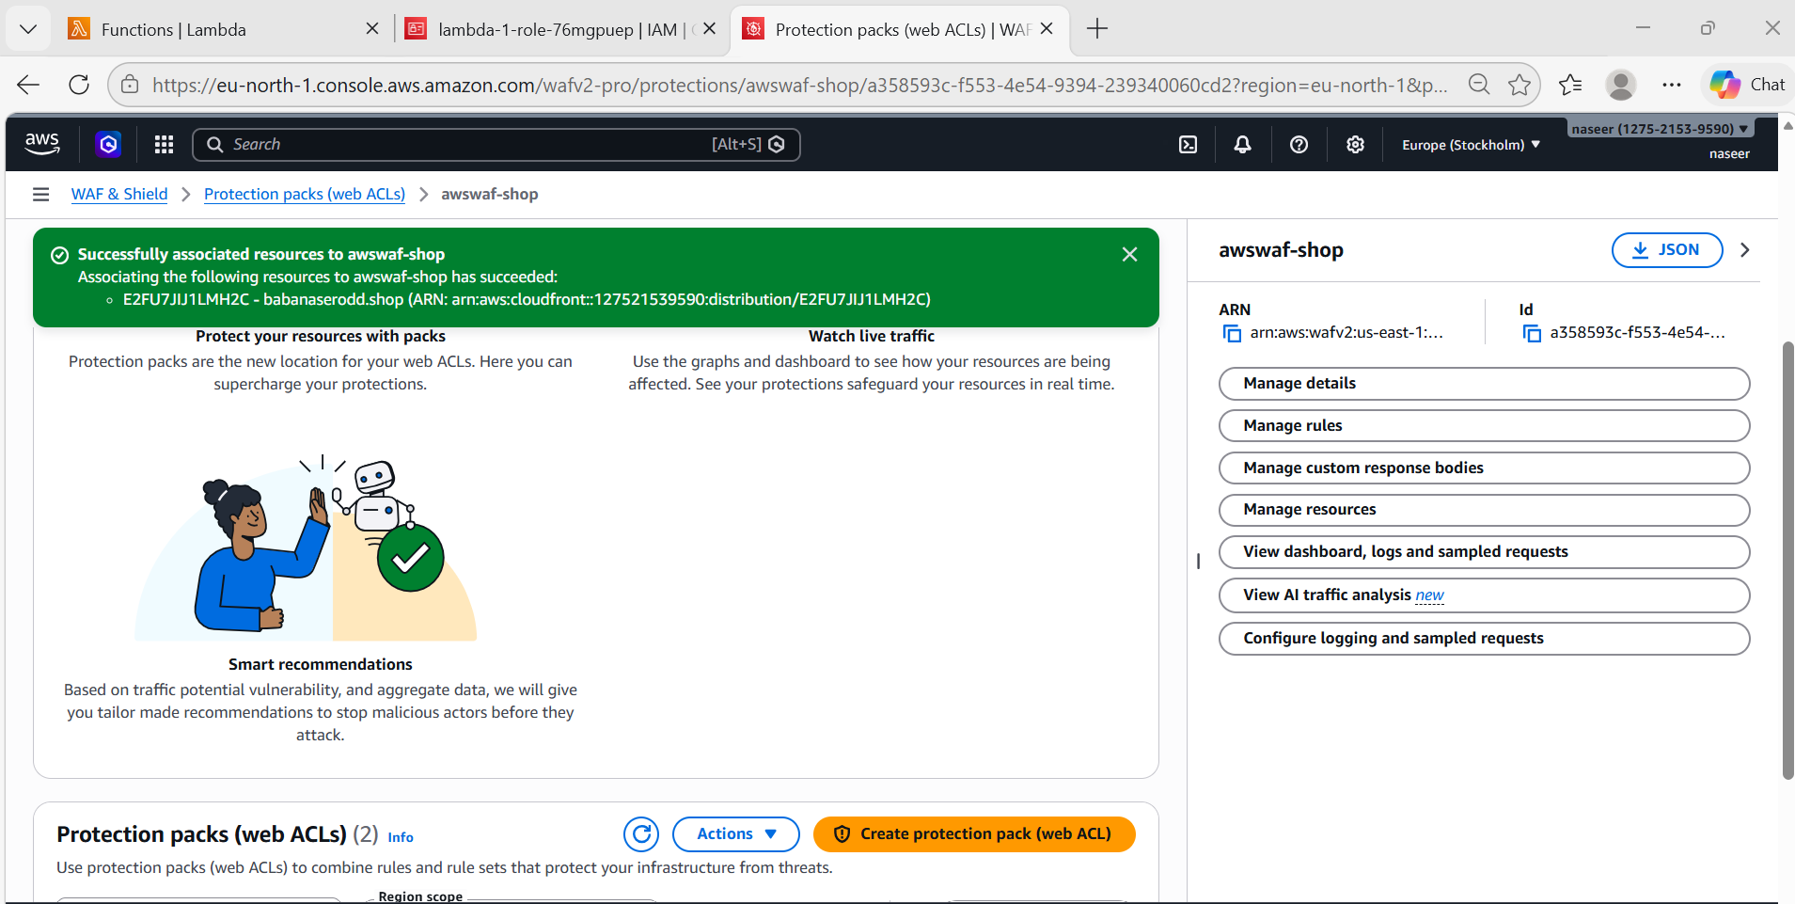
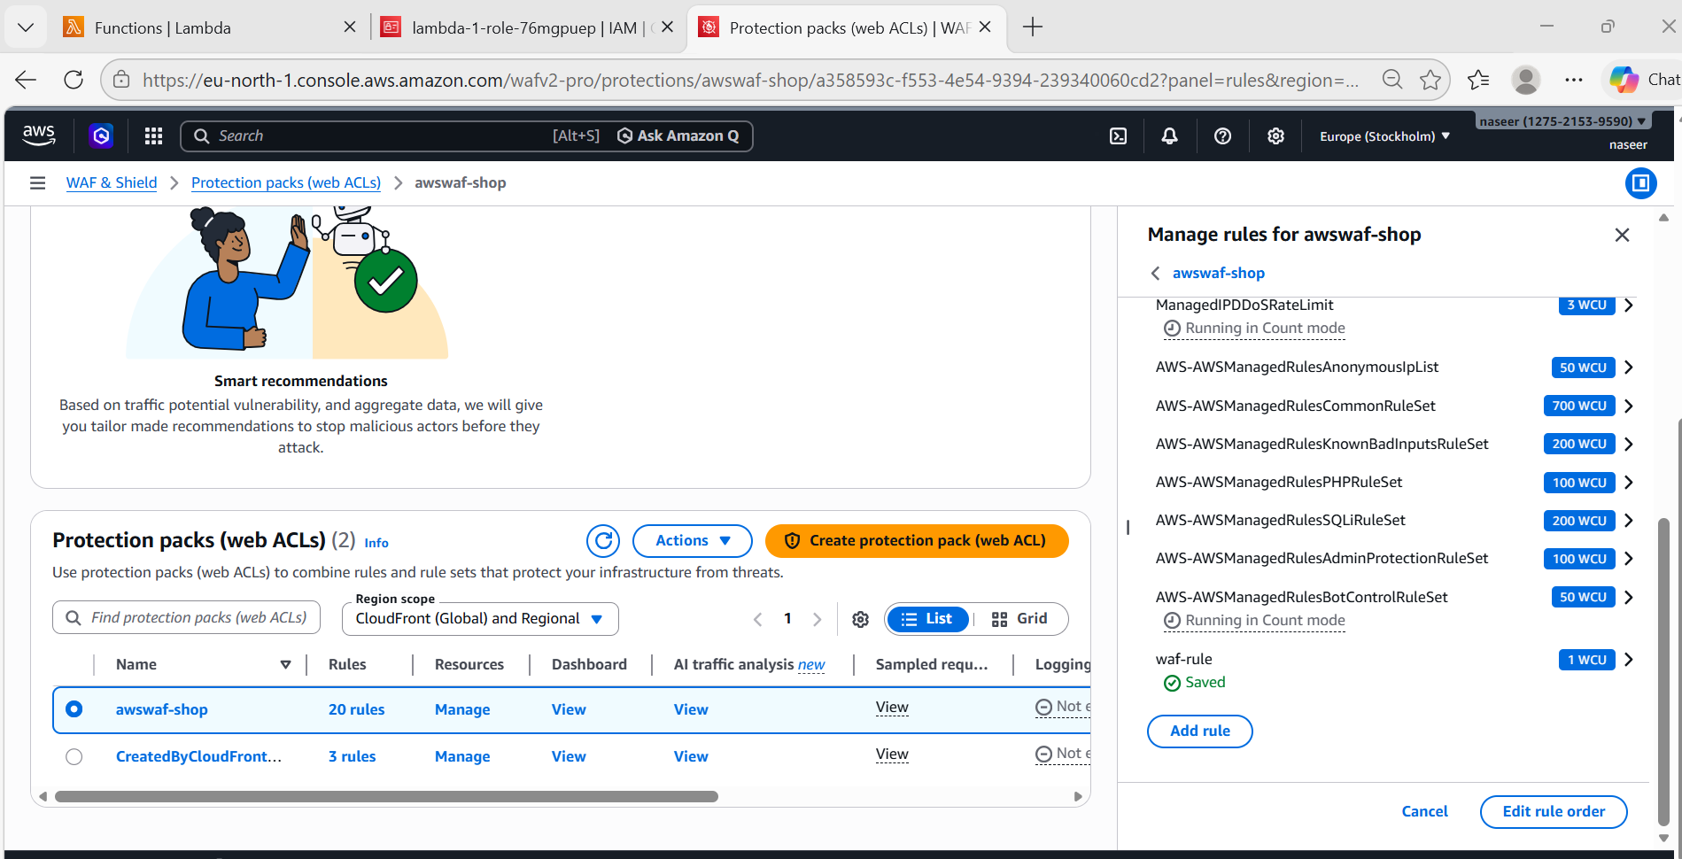
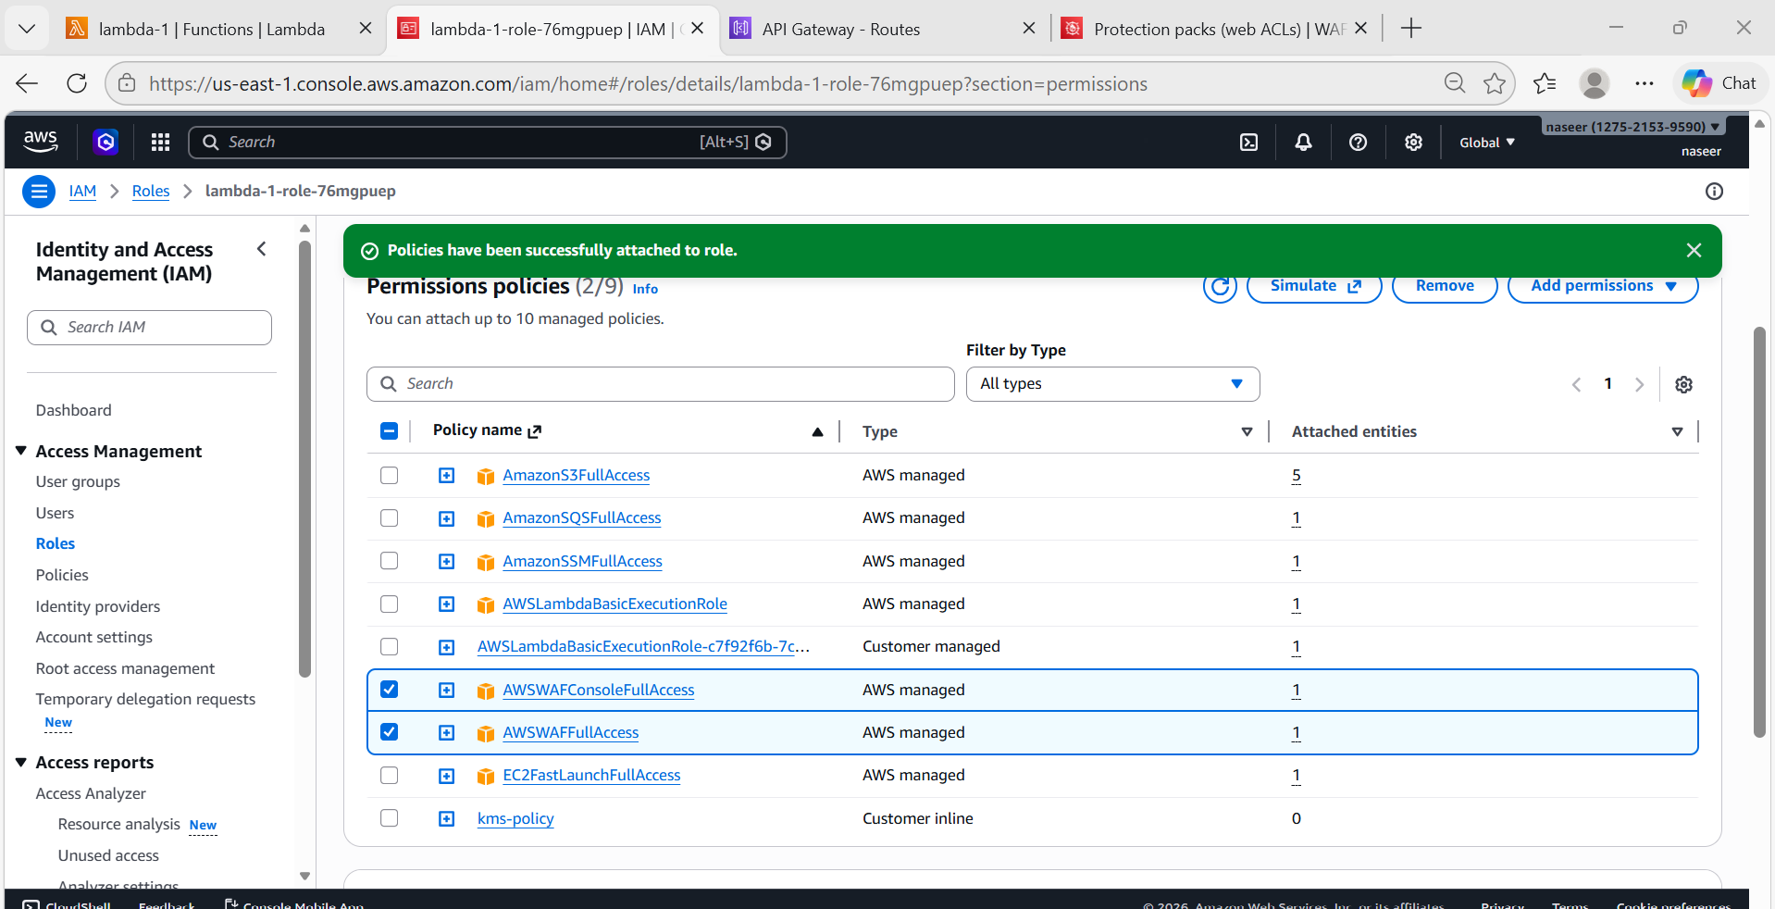
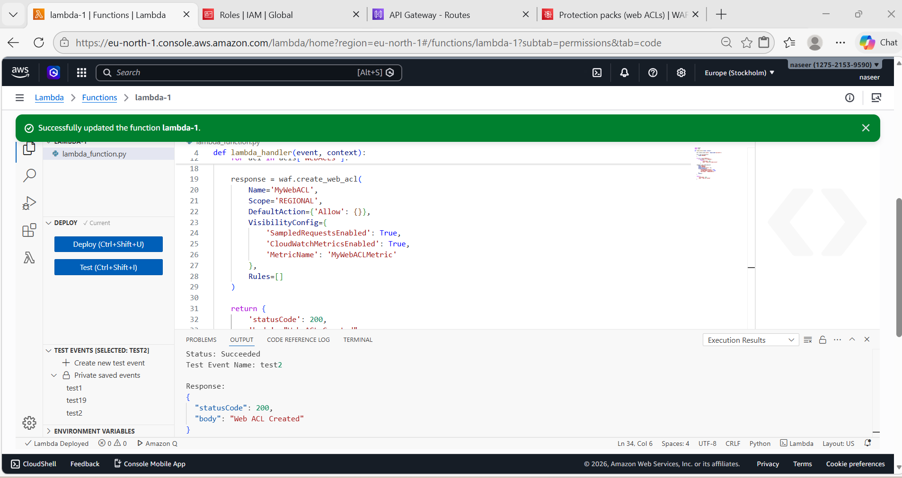
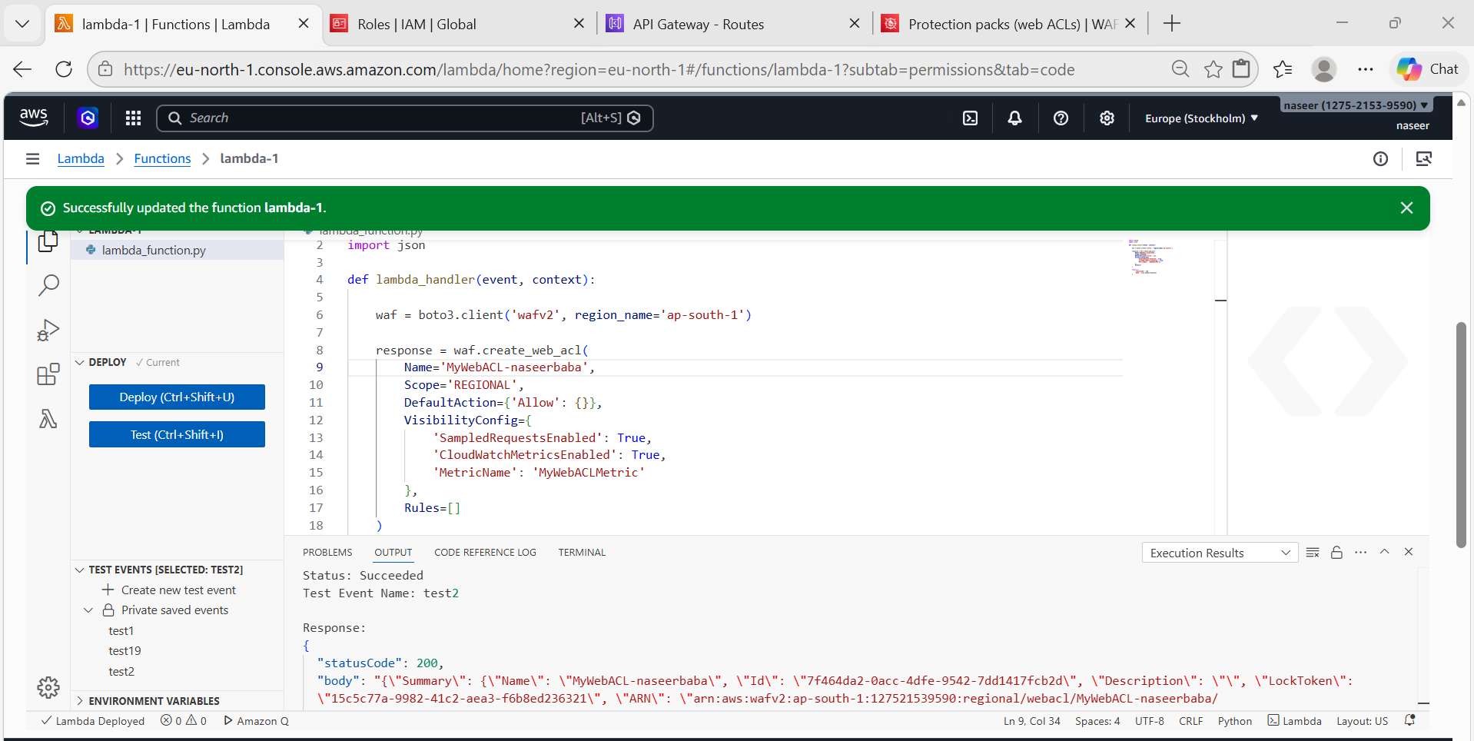
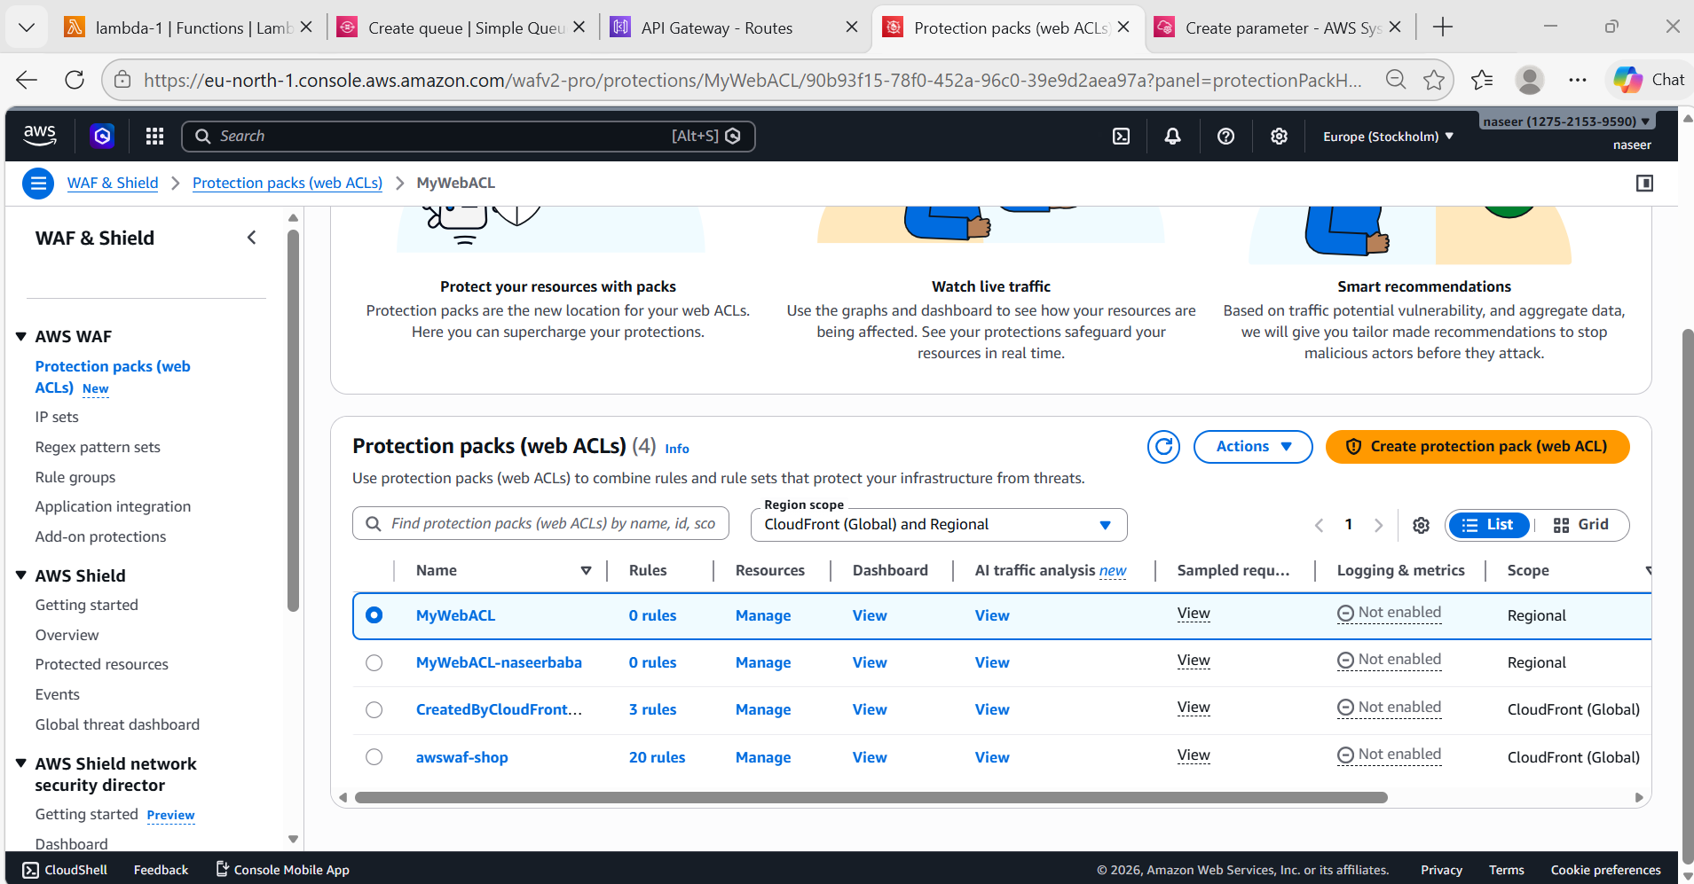

- Amazon SQS (Simple Queue Service)
Architecture Flow
User
│
▼
API Gateway
│
▼
Lambda
│
▼
SQS Queue
│
▼
Worker Lambda / EC2
│
▼
Database

Steps:
Open AWS ConsoleSearch SQSClick Create QueueChoose queue type
Standard
or
FIFO
Enter queue name :myqueue-1Create queue
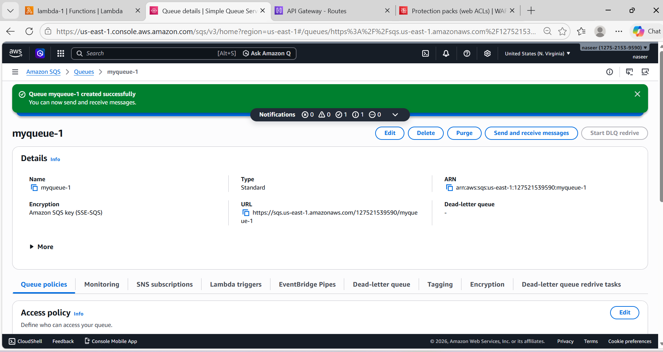
import boto3
sqs = boto3.client('sqs', region_name='us-east-1')
queue_url = "https://sqs.us-east-1.amazonaws.com/708035287026/order-queue"
def lambda_handler(event, context):
response = sqs.send_message(
QueueUrl=queue_url,
MessageBody='New Order: Product ID 123'
)
print("Message Sent Successfully")
print(response)
return {
"statusCode": 200,
"body": "Message sent to SQS successfully"
}
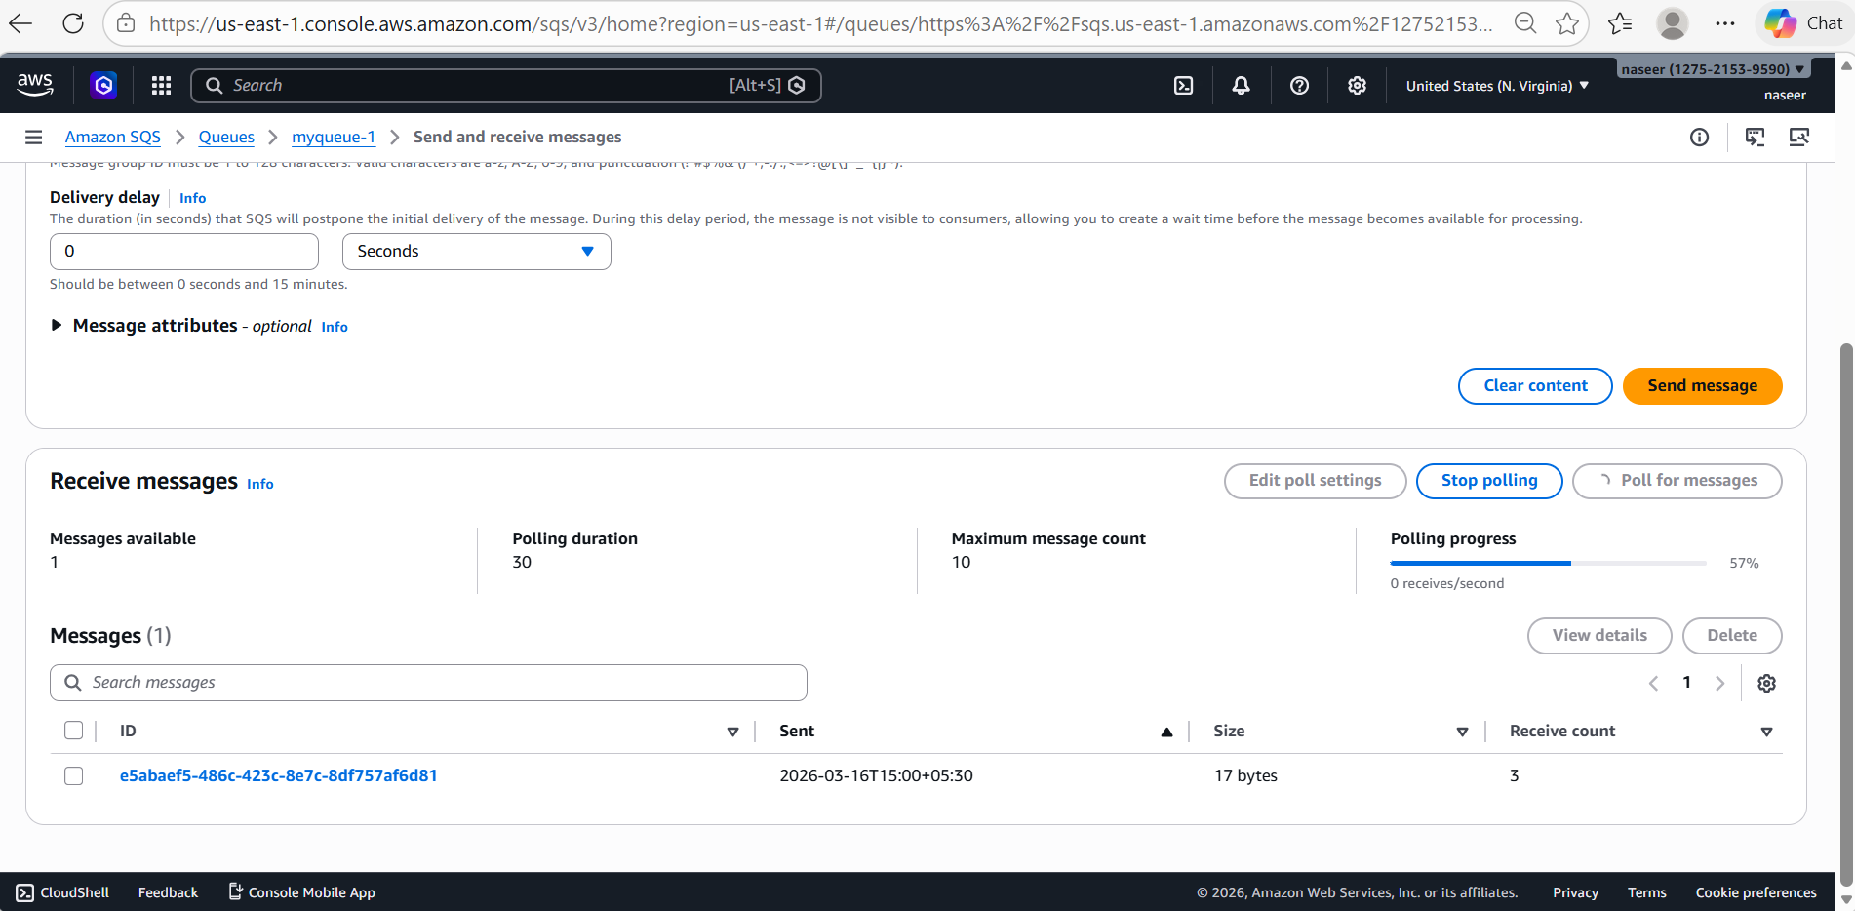
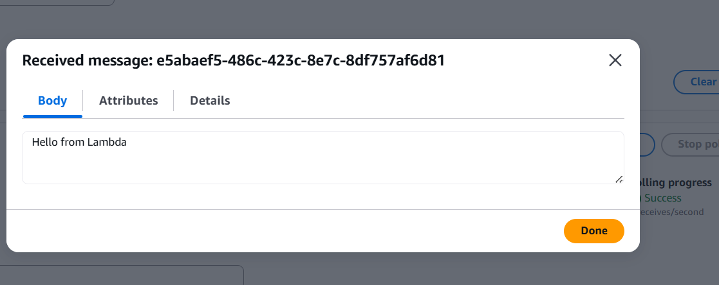
- Amazon MQ
Steps:
Open AWS ConsoleSearch Amazon MQClick Create Broker
Choose engine: ActiveMQ
or
RabbitMQ
Select instance type: mq.t3.microConfigure security and networkingCreate broker
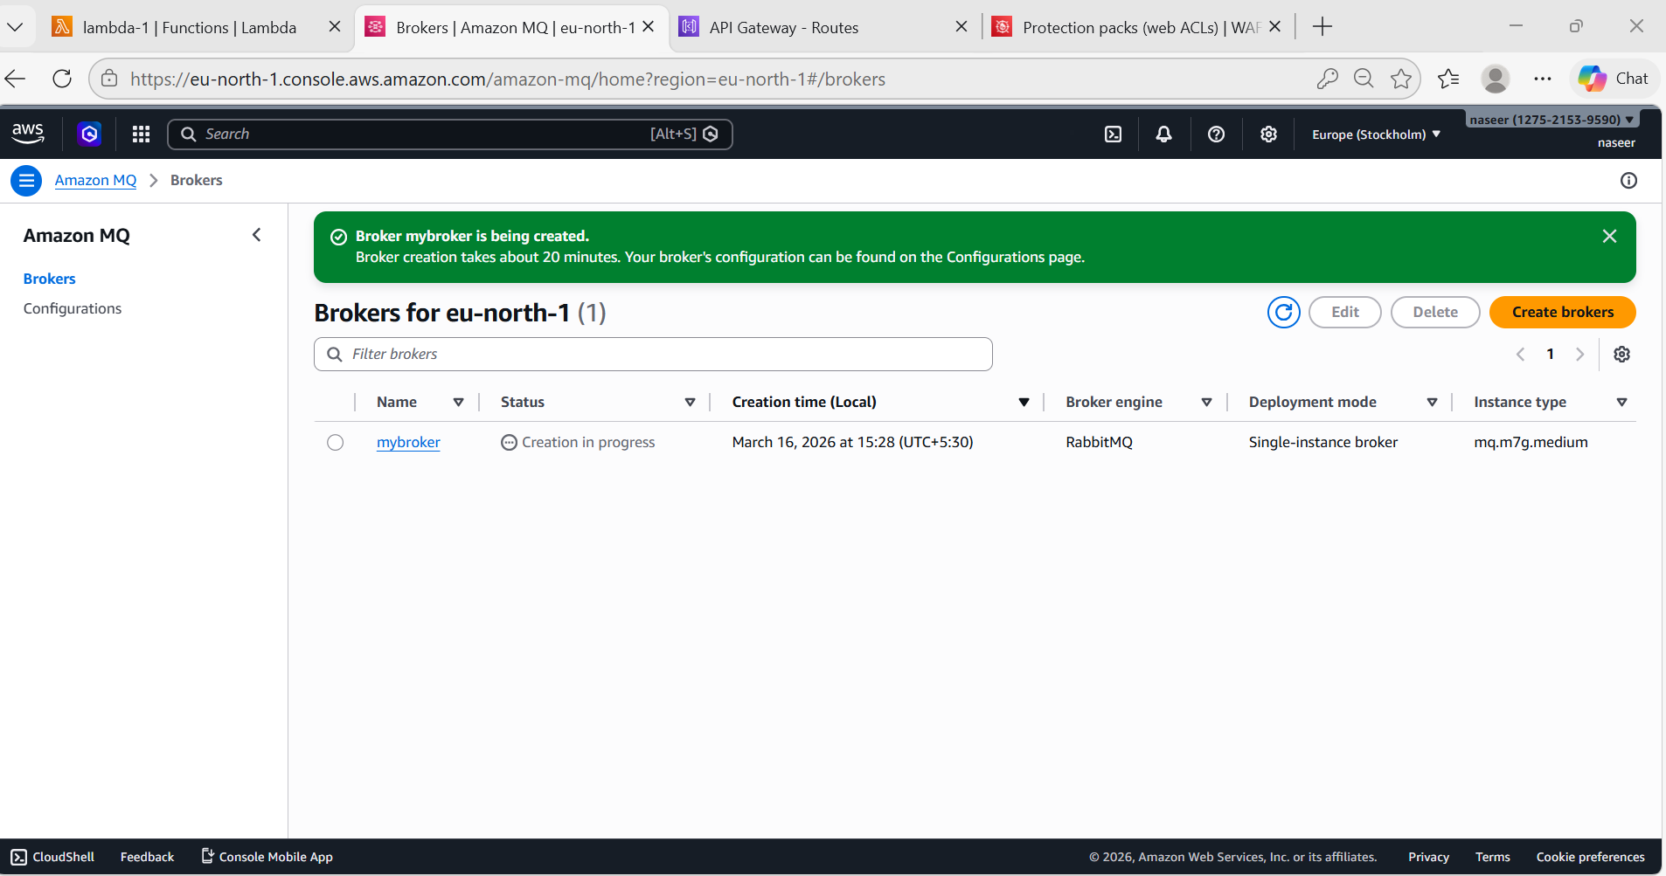
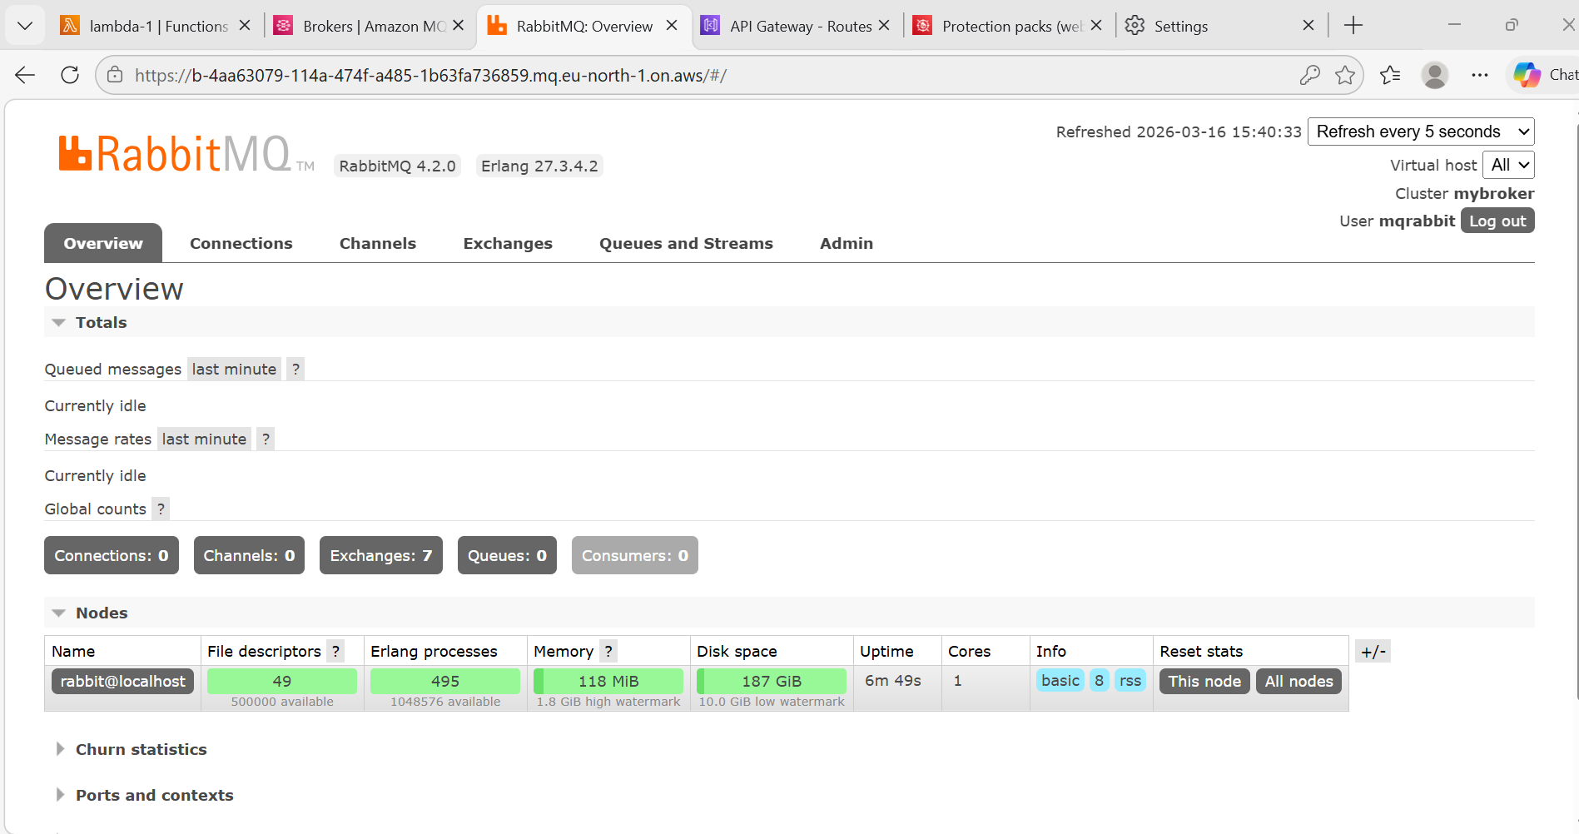
Program 1 — Connect to Amazon MQ (RabbitMQ Broker)
Steps:
- Create a Folder
On your local system or EC2 / CloudShell run:
mkdir rabbitmq_lambda
cd rabbitmq_lambda
pip3 install pika -t .

- Add Lambda Code
Create file: nano lambda_function.py
Paste this example:
import pika
def lambda_handler(event, context):
connection = pika.BlockingConnection(
pika.ConnectionParameters(' b-4aa63079-114a-474f-a485-1b63fa736859.mq.eu-north-1.on.aws:5671')
)
channel = connection.channel()
channel.queue_declare(queue='task_queue')
channel.basic_publish(
exchange='',
routing_key='task_queue',
body='Hello from Lambda'
)
connection.close()
return {
'statusCode': 200,
'body': 'Message sent to Amazon MQ'
}
Save.
- Copy your Lambda file into the folder
Move the file you created earlier:
mv ../lambda_function.py .
ls
- Create ZIP package for Lambda
zip -r lambda_mq.zip .
This creates:
lambda_mq.zip
Now you have the Lambda deployment package.
- Upload ZIP to AWS Lambda
Open AWS ConsoleGo to LambdaSelect your Lambda function
Click Upload from → .zip fileUpload lambda_mq.zipClick Deploy

import pika
import ssl
def lambda_handler(event, context):
host = "b-4aa63079-114a-474f-a485-1b63fa736859.mq.eu-north-1.on.aws"
port = 5671
username = "mqrabbit"
password = "9030233458baba"
credentials = pika.PlainCredentials(username, password)
# SSL setup (IMPORTANT for amqps)
ssl_context = ssl.create_default_context()
parameters = pika.ConnectionParameters(
host=host,
port=port,
credentials=credentials,
ssl_options=pika.SSLOptions(ssl_context)
)
connection = pika.BlockingConnection(parameters)
channel = connection.channel()
channel.queue_declare(queue='test')
channel.basic_publish(
exchange='',
routing_key='test',
body='Hello from Lambda via Amazon MQ'
)
connection.close()
return {
"statusCode": 200,
"message": "Message sent successfully"
}

Go to AWS Lambda → Upload from ZIP → Deploy
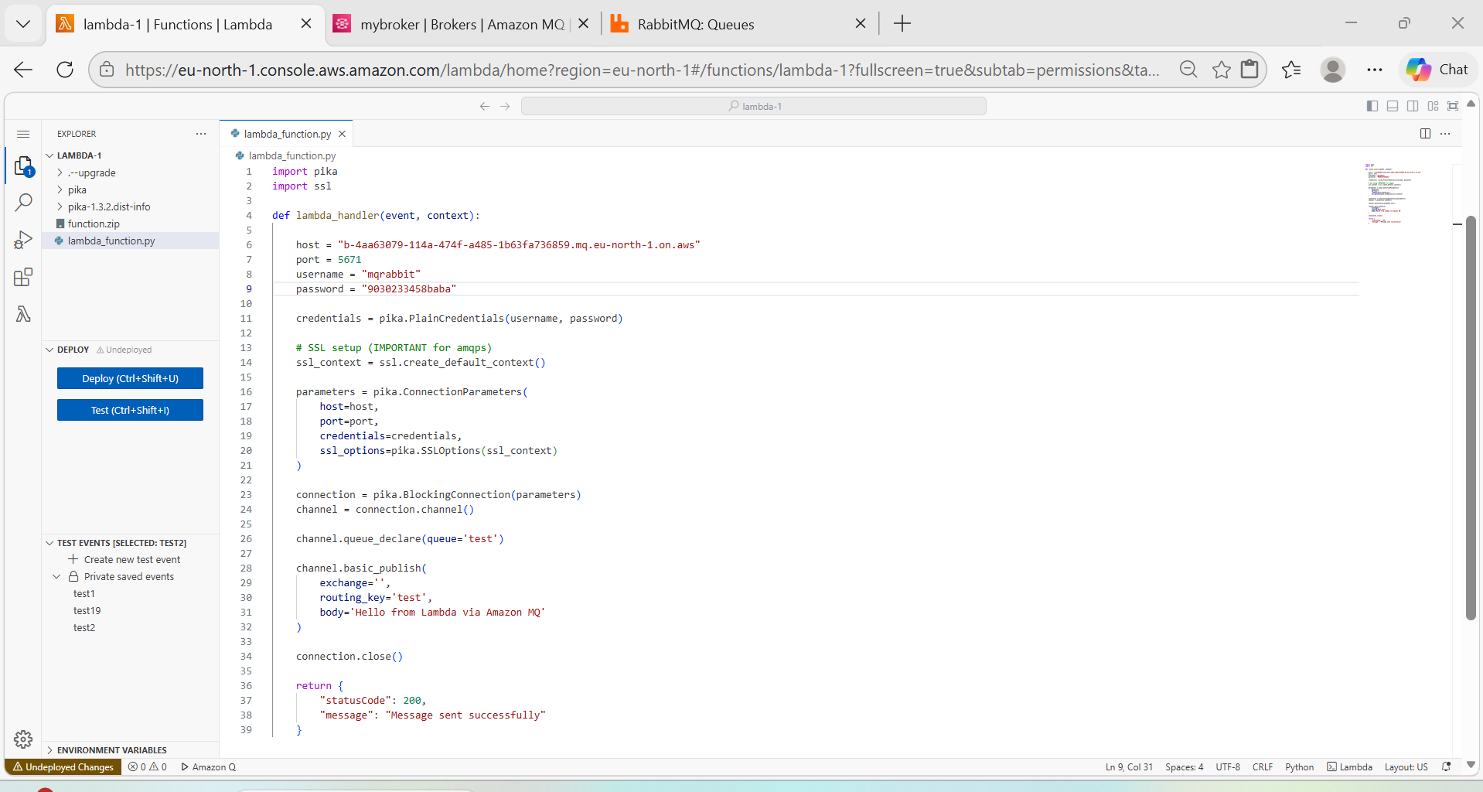
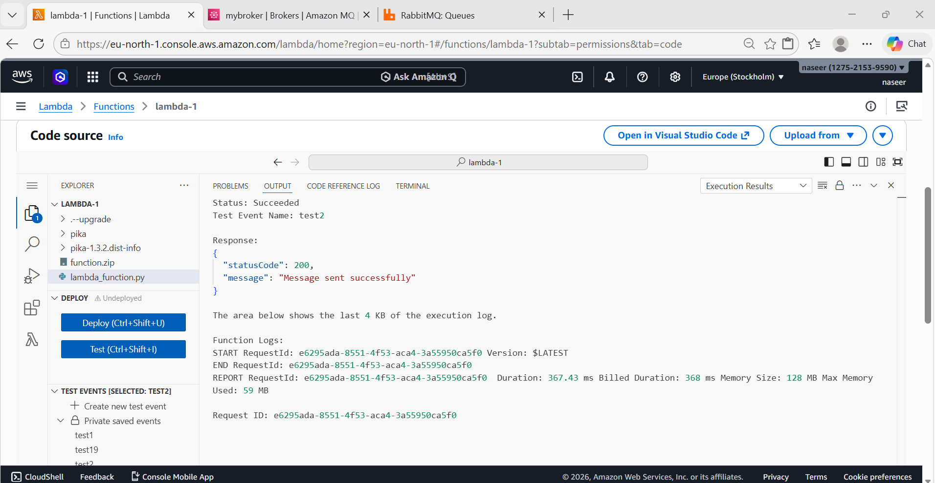
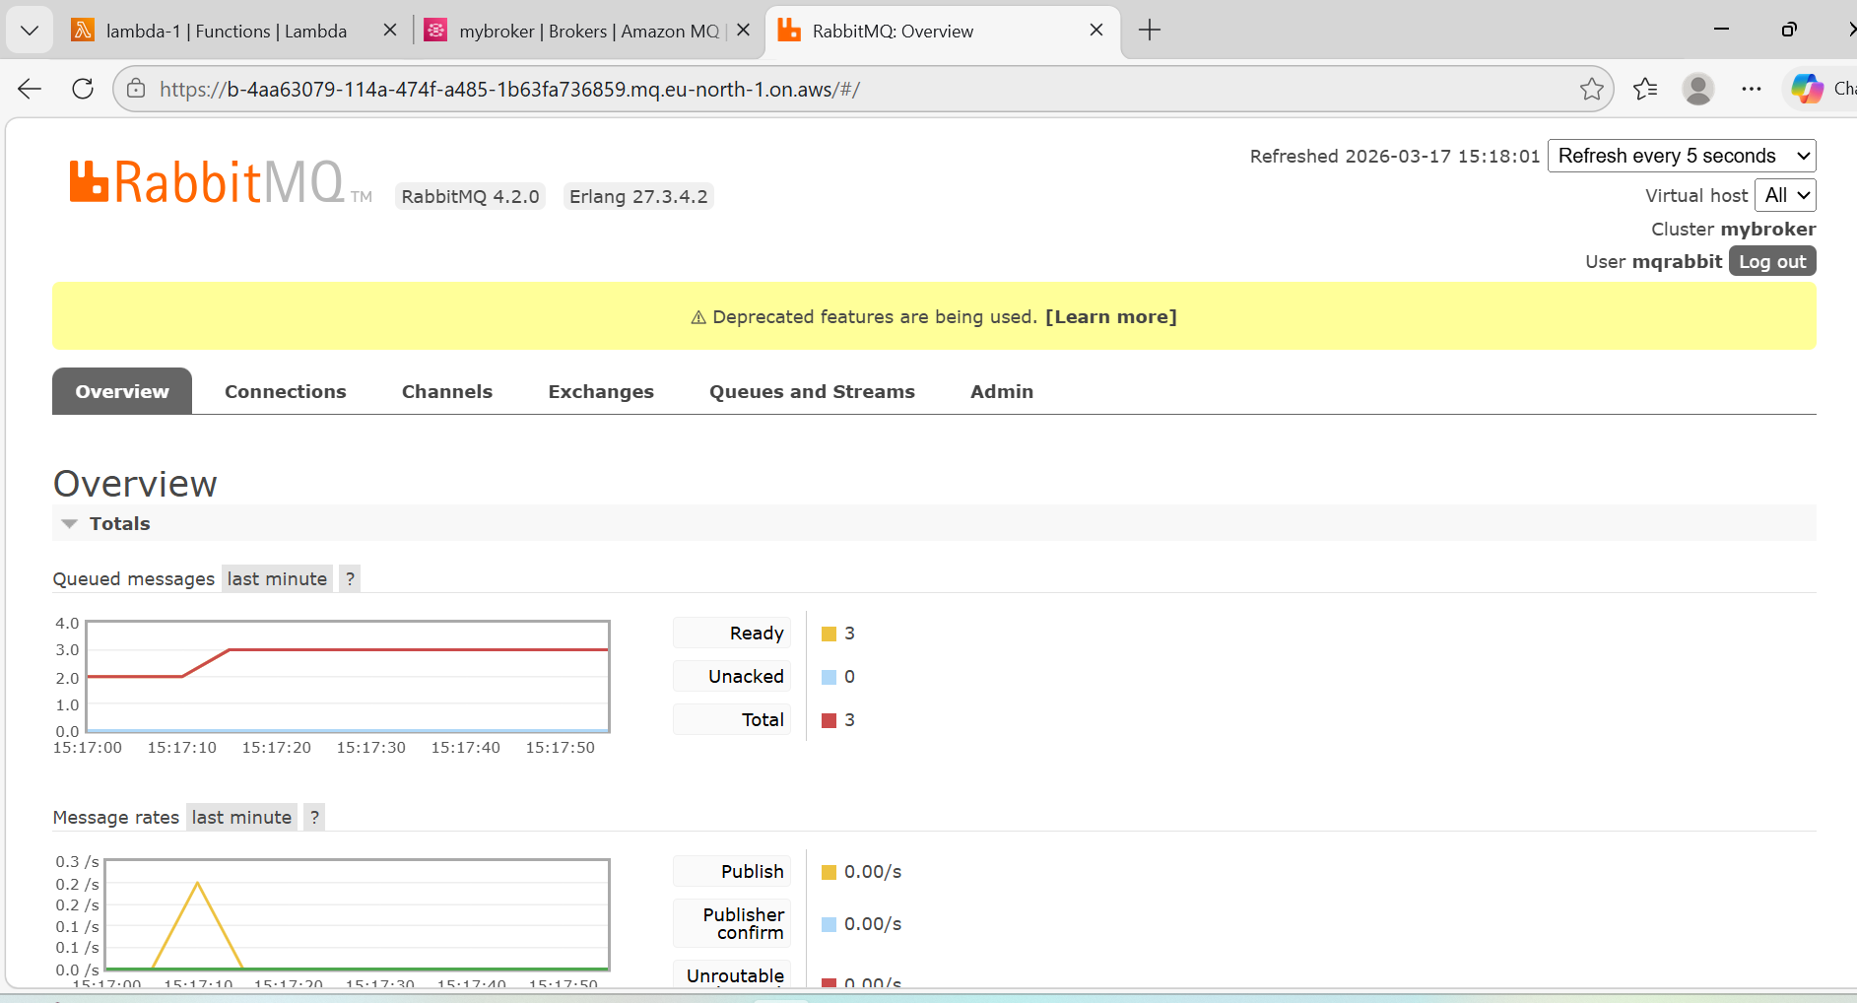

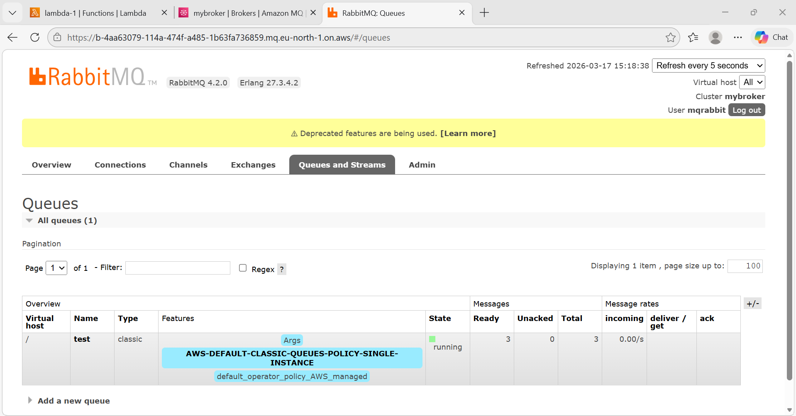

Architecture Flow
AWS Lambda

│ AMQPS (TLS) Port 5671
▼
Amazon MQ (RabbitMQ Broker)
│
▼
Queue : test
│
▼
Message stored

